**PO1_DGC_Digital Calculator**

**CDD Document**

**Version 1.0**

**Draft**

|  |  |  |  |  |
| --- | --- | --- | --- | --- |
| **Document Change History** | | | | |
| **Version** | **Author** | **Date** | **Change** | **Status** |
| 1.0 | - Alzahraa Mohamed | 24/1/2020 | * Initial creation | Draft |

|  |  |  |  |  |
| --- | --- | --- | --- | --- |
| **Document Change History** | | | | |
| **Version** | **Author** | **Date** | **Change** | **Status** |
| 1.0 | - Nada Mohamed | 3/3/2020 | * Initial creation | Draft |

|  |  |  |
| --- | --- | --- |
| **Reference Documents** | | |
| **Document Name** | **Version** | **Status** |
| SRS | 1.8 | Proposed |
| GDD | 1.3 | Proposed |

**Table of Contents**

**1.** **Project Description** 6

**1.1** **Software Context Diagram** 6

**2.** **Components** 7

**2.1** **ECUAL API’s** 7

**2.1.1** **KEYPAD** 7

**3.** **Configuration** 9

**Index of Figures**

Figure ‎1‑1 Software Context Diagram 6

Figure 2‑1 Software FlowChart 8

# **Project Description**

This project is a digital calculator that takes input from user and displays the input and the result on a screen.

The hardware used in the calculator is Keypad which takes input from user, LCD to display the result, buzzer to generate tunes on each key press and micro controller that performs all operations in the system.

## **Software Context Diagram**

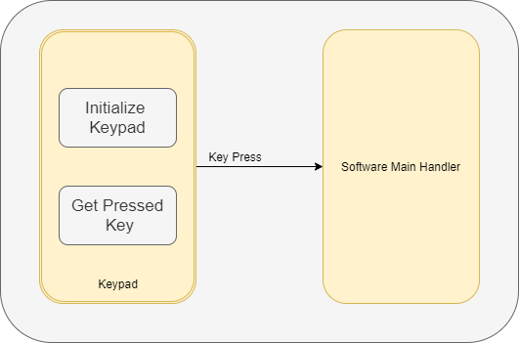

Figure ‎1‑1 Software Context Diagram

# **Components**

Clarifying the components mentioned in the layered architecture, their public API’s, arguments, return value and requirements covered.

## **ECUAL API’s**

### **KEYPAD**

#### Keypad Initiate

|  |  |
| --- | --- |
| Requirement ID | Req_PO1_DGC_CDD_001_V01 |
| Service name: | KEYPAD_errstatInit |
| Syntax | errstate KEYPDAD_errstateInit (void) |
| Sync/Async | Synchronous |
| Description | This API shall initiate keypad on its configured pins |
| Parameter (in) | * None |
| Parameter (out) | * None |
| Return Value | * errstate | OK : if everything is done correctly   NOK : if anything goes wrong. |
| Covers | * *Req_PO1_DGC_GDD_009_V01* |

#### Keypad Get Pressed Key

|  |  |
| --- | --- |
| Requirement ID | Req_PO1_DGC_CDD_002_V01 |
| Service name: | KEYPDAD_errstateGetKeyPressed |
| Syntax | errstate KEYPDAD_errstateGetKeyPressed (u8 * Copy_u8PtrKey) |
| Sync/Async | Synchronous |
| Description | This API shall get the keypad pressed key |
| Parameter (in) | * None |
| Parameter (out) | * Copy_u8PtrKey: pointer that holds the value of the pressed key |
| Return value | * errstate | OK : if everything is done correctly * NOK : if anything goes wrong. |
| Covers | * *Req_PO1_DGC_GDD_010_V01* |

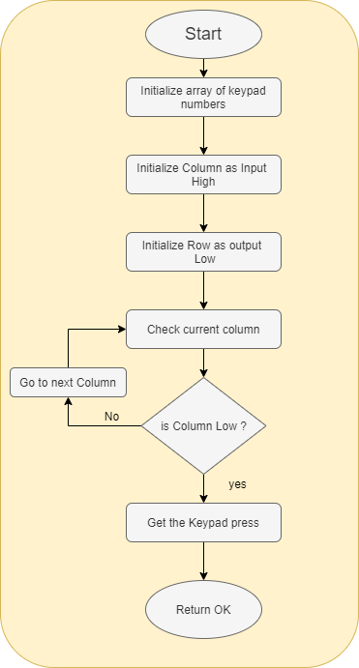

Figure 2‑1 Software FlowChart

# **Configuration**

|  |  |
| --- | --- |
| Name | KeypadConfig |
| Type | Structure |
| Element | *Keypad_Column*PORT  *Keypad_Row*PORT  *Keypad_Column*PIN  *Keypad_Row*PIN |
| Description | This Container contains the configuration parameters related to Keypad  PORT and PIN configuration. |

|  |  |
| --- | --- |
| Name | Keypad_ColumnPORT |
| Parent Container | KeypadConfig |
| Description | To configure the column port of Keypad . |
| Post-Build | true |
| Pre-Build | false |
| Scope | local |

|  |  |
| --- | --- |
| Name | Keypad_RowPORT |
| Parent Container | KeypadConfig |
| Description | To configure the Row port of Keypad . |
| Post-Build | true |
| Pre-Build | false |
| Scope | local |

|  |  |
| --- | --- |
| Name | Keypad_ColumnPIN |
| Parent Container | KeypadConfig |
| Description | To configure the column pin of Keypad . |
| Post-Build | true |
| Pre-Build | false |
| Scope | local |

|  |  |
| --- | --- |
| Name | Keypad_RowPIN |
| Parent Container | KeypadConfig |
| Description | To configure the row pin of Keypad . |
| Post-Build | true |
| Pre-Build | false |
| Scope | local |